CORE WORD: Name
For Educators, Related Service Providers and Parents
Wait Time: Last month we addressed Aided Language Stimulation, this month we take a look at wait time. Providing adequate ‘wait time’ is an important consideration for communication partners while interacting and engaging with persons who use AAC systems. Sometimes the need to ‘wait’ may seem uncomfortable at first but over time, practice and when given focused attention, the amount of wait time needed for each individual will become more natural. As communication partners we can wait expectantly for AAC users to respond and engage.
WAYS WE CAN USE THE WORD
ASK QUESTIONS (e.g. your name?)
DIRECT ACTION (e.g. write my name)
SHARE INFORMATION (e.g. my name Alisa)
ROUTINES AND SCHEDULES
Arrival: Adults can encourage students to find their name and put their backpack where their name is upon arrival (e.g. “Put your backpack by your name”).
Circle: Adults can prepare students names’(and their picture) laminated and taped to the carpet or on their chairs. Students can practice finding and sitting on or next to their name during circle time (e.g. “Sit by your name”).
Adults can make a point to intentionally greet everyone by name during circle time and encourage students to do the same. Once students have caught on to this routine, adults can present different students’ names to the class and ask “who’s name?” students can look at, point too, or say the chosen student’s name out loud.
Snack/mealtimes: Adults can set up the lunch/snack table with name tags (the name tags can have a picture of the student to reinforce their name) and students can find their name to sit by (e.g. “sit by your name”).
PLAY
Toys and Games:
During imaginative play, students can choose to play with babies, puppets, stuffed animals, action figures or any other beloved character to practice asking for and telling their names to (e.g. “your name?”, “my name Mater”). Adults can support students in this dialogue by providing many opportunities and models (e.g. “who is your friend? What name?”). Another way adults can provide more opportunities is to keep introducing new stuffed animals/action figures and say “Hi! My name (insert random name here).”
Recess
During recess, adults can support students in writing their name in chalk outside on the ground. Students can tip toe, stomp, run, or jump on their name for fun!
If there is somebody who looks like fun to play with, adults can support students in asking a new friend what their name is at recess.
READING
Here are some suggested books on YouTube that can assist in teaching the core word:
Children's Books Read Aloud: Hello My Name Is Ruby by Philip C. Stead │ Once Upon A Story
"Alma and How She Got Her Name" by Juana Martinez Neal (read by Sen. Laura Sturgeon, 4th District)- DSEA Literacy Channel
Thunderboy Jr. by Sherman Alexie Read Aloud by Read Me A Book
SOCIAL INTERACTIONS AND VIDEO MODELING
With support from adults students can go on a “Name Scavenger Hunt” around their school or classroom. Students can bring their name tag with them and introduce themselves to new friends, “My name Alisa.”After they have shared their name, students can ask their new friend what their name is (e.g. “you/your name?”).
SENSORY MOTOR
Students can “write” their name with their bodies by moving their legs and arms as if they are writing their names in the air.
This video can help with body letter movement ideas! All of us have very different bodies, and this may be tricky for some students to participate in depending on their body. If that is the case, maybe they can direct you to spell their name for them!
Body Letters Alphabet Song | Make Letters With Your Body | ESL for Kids | Fun Kids English
Name Dance Party: Students can participate in a dance party. Adults can hold up the students name tag, their picture as well as say their name out loud so that the students know it is their turn! When they hear or see their name it is their turn to do a dance move. Adults can model this new activity by taking a turn first.
STRUCTURED ACTIVITIES
TPK Learning - K12 Grade 1 - English: Introducing Yourself
Teach students about a name. Adults can also take this time to touch on nicknames and students can share if they have a nickname or what they want it to be!
ART OR SCIENCE ACTIVITIES
My Name/You(r) Name Tag: Students and adults can create their own name tag that has their name written very large, and include any other helpful information.
On the back of the name tag it can say “your name?” or “what is your name?” This can be taken on the “Name Scavenger Hunt” to serve as a visual aid for everyone involved to support students in asking for someone’s name.
USE OF APPS OR OTHER TECHNOLOGY
Pictello: Using paid app Pictello (or any other story generating app, google slides, powerpoint, ect) create a story for the students. With permission, adults can take pictures of these activities to look over with the students including the icon sequence for “name” in order to make modeling easier for all communication partners! Read the story with the student.
VIDEOS, MUSIC, ANIMATED SHORTS
What's your name?, Self-introduction Lesson, English for Children - FreddiesVilleVideos
What's Your Name? Kids Song Kids Academy
WORD WALL: Create a WordWall and add ‘name’ to the list.
READING and the Word Wall: Sound out the letters together. Have the students find the word on the AAC system.
WRITING and the Word Wall: Using a pencil or alternative pencil, have students try to type the word on the keyboard or write the word together.
Choosing Words for the Classroom Word Wall with Dr Caroline Musselwhite Video
For specific questions or more ideas regarding this core word Activity Sheet, please contact Alisa Lego @newfriendscollective on instagram.
Thank you!

CORE WORDS: Do
For Educators, Related Service Providers and Parents
Wait Time: Last month we addressed Aided Language Stimulation, this month we take a look at wait time. Providing adequate ‘wait time’ is an important consideration for communication partners while interacting and engaging with persons who use AAC systems. Sometimes the need to ‘wait’ may seem uncomfortable at first but over time, practice and when given focused attention, the amount of wait time needed for each individual will become more natural. As communication partners we can wait expectantly for AAC users to respond and engage.
WAYS WE CAN USE THE WORD
SHARE INFORMATION (e.g. I do lots of things)
COMMENT (e.g. I do like that)
TELL SECRETS (I think they do)
ASK QUESTIONS (e.g. Where do you like to go? Do you like ____?)
ANSWER QUESTIONS (e.g. Yes, I do.)
AGREE (e.g. I do).
EXPRESS A FEELING (e.g. I do feel happy)
CLARIFY (e.g. What do you mean?)
COMPLAIN (e.g. I do not like it)
MAKE CHOICES (e.g. Which one do you want?)
ROUTINES AND SCHEDULES
Going to recess: Students can have an opportunity to ask a student what he or she wants to do. Such interactions can be facilitated by an adult, role playing beforehand, with visuals or a social script.
Getting dressed: Classic Sesame Street - I Can Do It By Myself (Better Quality)Talk about how they are trying to do it by themselves. Can they do it? What are they doing?
Schedules: With adults using Aided Language Stimulation, they can model by posing the question, ‘What are we going to do next?”
PLAY
Adults can narrate what students are doing using their voice and the talker, (e.g. you do play doh, or you do paint). Provided pause and wait time, student may need more prompting of scaffolds indicating what they are doing.
When appropriate during play, adults can ask what the students like to do and can comment on what they, in turn, like to do.
Adults can ask students what they want to play with by providing two modeled choices, (e.g. Do you want ____ or ______?).
Students can take turns by indicating, (e.g. I do, my turn).
Adults can ask which students want to pick a song or answer a question, and adults can model by saying, ‘my turn first’ and say, “I do” on the talker. When asked who’s next, (being provided pause and wait time) the students can indicate with or without a model, (e.g. I do).
Students can hide something in the room. Then when students look for it, they can ask, (do you want a clue?) (do you want the answer?), (do you know where it is?)
READING
Here are some suggested books on YouTube that can assist in teaching the core word:
There's Nothing To Do By Dev Petty | Children's Book Read Aloud, By Lights Down Reading
Do You Like Broccoli Ice Cream? | Super Simple Songs

Where Do Steam Trains Sleep at Night | Kids Books by StoryTime Train

Mama, Do You Love Me? by Barbara Joosse|Books Read Aloud|StoryTimeWithMsMelange
WHAT DO YOU DO WITH A CHANCE? by Kobi Yamada and Mae Besom - PV - Storytime

Living Books - Green Eggs And Ham (Read To Me)
SOCIAL INTERACTIONS AND VIDEO MODELING
Provide two students (at a time) the opportunity to put on a puppet show, (scripted) about what they do at school. (Provide the use of visuals as needed, as well as practice sessions with aided language stimulation and ample wait time for students to locate and express messages.
Video Modeling - Asking a Friend to Play by Meredith Harrah

SENSORY MOTOR
Reading the Eric Carle Book, Head to Toe, the students can make many movements and answer the questions by saying, “I can do it.”
From Head To Toe l New Version!!! l Eric Carle l Animal Sounds l Read-A-Loud l Read-Along by Teacher Alee
Students with other physical challenges could participate by accessing other instruments to participate or iPad instrument apps, (e.g. Keezy) to play along with the music if they are not able to perform the movements.

STRUCTURED ACTIVITIES
The adults and students can write about all that they did during the day so that students can have the opportunity to share the information with their families when they go home. Using a predictable writing chart in Google Slides the teachers can write (given class collaboration) what happened during the day and then share the document with the family.

I do many things at school-
I do ________________
I do ______________
I do __________________
I do ________________
I do ________________

VIDEOS, MUSIC, ANIMATED SHORTS

The Muffin Man | Kids Songs | Super Simple Songs

Sesame Street: Do De Duckie With Ernie

Do Song

Do You Want to Build a Snowman? (From "Frozen"/Sing-Along)
Young Adults
The Police - De Do Do Do, De Da Da Da

Dancing With The Stars Hustle Group Dance “Do the Hustle”

ART OR SCIENCE ACTIVITIES
Students can create these soft popsicles out of pompoms, working on fine motors skills and they can practice asking, (e.g. Do you have _____(color). Adults can respond, “Yes I do.” Adults can also provide choices of colors for students using Aided Language Stimulation, (e.g. Do you want ___ or ____)?

POMPOM ICE POPS- Highlights Magazine
BY LISA GLOVER

USE OF APPS OR OTHER TECHNOLOGY

Students can play the free online game, Snakes and Ladders with peers. Students take turns playing the game, indicating my turn or I do, or I go.
https://toytheater.com/snakes-and-ladders/

CookieDoodle App: Students can make cookies, using clear graphics, and make choices regarding shapes, flavors, and then take turns putting in ingredients, decorating the cookies and ultimately eating them. Students can indicate when it’s their, (e.g. I do), to put in ingredients, decorate or eat.

Use Clicker Writer for writing words, phrases or sentences with picture support as well as word banks to support a writing activity with a focus on the word, ‘do.’

Abilipad app could also be used for writing with use of pictures, adaptable keyboard, word banks, and word prediction. https://appytherapy.com/abilipad/

WORD WALL: Add the word, do on the Word Wall.

READING and the Word Wall: Sound out the letters together. Have the students find the word on the AAC system.

WRITING and the Word Wall: Using a pencil or alternative pencil, have students try to type the word on the keyboard or write the word together.

Choosing Words for the Classroom Word Wall with Dr Caroline Musselwhite Video

For specific questions or more ideas regarding this core word Activity Sheet, please contact Michaela Sullivan @ michaelasullivan2@gmail.com
Thank you!

CORE WORDS: Read
For Educators, Related Service Providers and Parents
This activity sheet will provide both activities for students and information to adults about various types of reading interventions and approaches.
Wait Time: Last month we addressed Aided Language Stimulation, this month we take a look at wait time. Providing adequate ‘wait time’ is an important consideration for communication partners while interacting and engaging with persons who use AAC systems. Sometimes the need to ‘wait’ may seem uncomfortable at first but over time, practice and when given focused attention, the amount of wait time needed for each individual will become more natural. As communication partners we can wait expectantly for AAC users to respond and engage.

WAYS WE CAN USE THE WORD
SHARE INFORMATION (e.g. I read a book)
COMMENT (e.g. good book)
ASK QUESTIONS (e.g. Did you read it?)
ANSWER QUESTIONS (e.g. I didn’t read it)
DIRECT ACTIONS (e.g. You read it).
SHARE NEEDS (e.g. I need to read a book and write a book report).
GET HELP (e.g. Can you help me read it?)

ROUTINES AND SCHEDULES
Arrival: After greeting the student, the Adults can remind the students to read the assignment on the board or to look at and/or read the schedule.
Going to bed: Adults can give students a choice of what book they want to read, (do you want _____ or _______) and expectantly wait for a choice response.
Shared Reading time: Students can be provided with a choice of two books to read during shared reading.
Circle Time: Students can select the book they want to read and majority rules.

PLAY
After having read their favorite books, during play time, students can make a choice between two books and act like one of the characters in the book, role-play, act-out or make sound effects related to the story, (e.g. animals, vehicles).
Students can pretend that they are the adults and read to a group of students by telling others what they remember or what they see in the book or what they remember hearing.
READING
Here are some suggested books on YouTube that can assist in teaching the core word:
An Elephant & Piggie Book, "We Are in a Book!" read aloud. By Mo Willems by Story Books Read Aloud
Grover reads The Monster at the End of This Book by Jon Stone video created by: Aaron Barnes
SOCIAL INTERACTIONS AND VIDEO MODELING
At morning meeting(s), adults can provide a choice of two books that can be read aloud in the circle/meeting. Students can take turns being the teacher, asking each student which book they want to read and then they can tally the answers.
Students can announce the book that is going to be read by reading the title, repeating the title after a model or describing the book using verbal speech or their AAC system(s).
SENSORY MOTOR
Students can create their own mini books. They can illustrate and write on them either independently or while working with an adult and an alternative pencil to write. Then comes the fun part….READING their book.
Here is a mini-book template by twinkl.com
STRUCTURED ACTIVITIES
This topic is very near and dear to my heart. After working with preschool students with and without significant disabilities I have found the Dialogic Reading approaches described below to be highly effective in therapy sessions. These help to support the development of vocabulary, overall language skills, attention, interest in books, critical thinking and more. Books provide a wonderful context for individuals to learn language and to relate their own experiences and students often love to read and re-read their favorite books.

Here is an extensive video by Dr. Lonigan on Dialogic Reading (Implementing Level 1 and Level 2 and Level 3 approaches) which he describes as “A scaffolded language interaction about a book.”

What is Dialogic Reading? It is an active-engaged type of shared reading. It is less about the book and more- a discussion about the book, which helps to increase vocabulary, critical thinking, overall language skills and more. It is reportedly best provided in groups of 3-5 students).

Here are some dialogic reading supports and prompts to utilize when engaging in shared reading activities with your students. All of the information below can be found on the Reading Rockets website:

The fundamental reading technique in dialogic reading is the PEER sequence where the adult: Prompts the student to comment on the book, Evaluates their response, Expands upon what they said and then Repeats the prompt to make sure they learned from the expansion. Doesn’t this sound like so much of what we already do in our Speech and Language sessions, lessons and while reading books at home with our students. This is validation that you ARE helping your students just by talking about the book and having fun with the book.
Additionally,there are prompts that are described in the above website that make so much sense. You can remember each by remembering the pneumonic: CROWD. Here they are:
Completion prompts (Adults have the student complete a phrase or sentence about what they see in the book, e.g. That is a ____).
Recall prompts: (Adults ask the students questions about the book to see if they can remember what happened)
Opened Ended Questions: Asking open ended questions allow students to think for themselves and generate their own novel ideas, (e.g. what do you see?).
WH questions: Ask them WH questions in the book to see if they know what the items are or what they think is happening.
Distancing- Relate the story to their own lives. This is the clincher. This is when the student begins to relate to the text to eventually gain a better understanding of themselves and the information that they hear and receive.
How fun is this approach? Any book can be a built in therapy/educational tool for a contextual conversation.

VIDEOS, MUSIC, ANIMATED SHORTS

The Reading Song- World Book Day 2019 By Newington CPS

Reading Song | CoComelon Nursery Rhymes & Kids Songs

I Love Reading - Reading and Book by the Fabulous Lemon Drops Song
Book Song! | We Love Books! | Original Songs | By LBB Junior by Moonbug Kids- Cartoons and Kids Songs

Reading (Happy Song) by Adreanna Clark

This section focuses on literacy instruction by Dr. Caroline Musselwhite- For Educators, Related Service Providers, Parents and more!

Symbols and Learning to Read with Dr Caroline Musselwhite

Good Literacy Instruction is Good for All Students with Dr Caroline Musselwhite

Young Adults
Engaging Older Students with Dr Caroline Musselwhite
ART OR SCIENCE ACTIVITIES

Students can write a book, it can be about themselves or something else. BUT make sure they decorate the cover in whatever they want with anything they want to create their own art.

USE OF APPS OR OTHER TECHNOLOGY
I Like Books app, (free) 37 Picture Books in one, by Grasshopper apps, (free) (e.g. I like animals, I like boas, I like cats, I like dogs). Users can have the book read to them, they can read it by themselves or have it autoplay, listening to it and the page can turn automatically. Students can customize their story and even read and record it in their own voice.

Tarheel Reader- A Free, accessible resource of books created by accomplished authors and the community that can be read aloud via computerized speech. In addition to reading the books and search for topics, readers can also create and publish books on this site.

Tarheel Shared reader The Shared reader website provides the student/reader with access to vocabulary at the bottom of the book to engage more in book reading by using core words to express a variety of communication functions.

Bitsboard app: Is a Fun, learning app with numerous games and activities that are created and modified by the user or created by the community. Here is a snapshot of the various games that in part can address reading skills
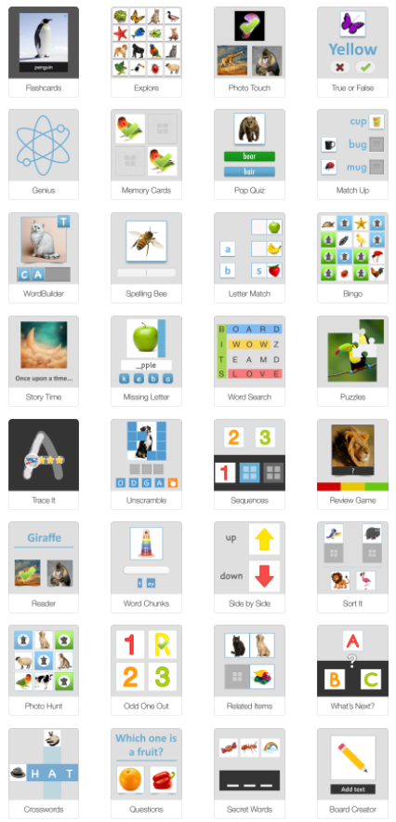

WORD WALL: Add the word, read on the Word Wall.

READING and the Word Wall: Sound out the letters together. Have the students find the word on the AAC system.

WRITING and the Word Wall: Using a pencil or alternative pencil, have students try to type the word on the keyboard or write the word together.

Choosing Words for the Classroom Word Wall with Dr Caroline Musselwhite Video

For specific questions or more ideas regarding this core word Activity Sheet, please contact Michaela Sullivan @ michaelasullivan2@gmail.com
Thank you!

CORE WORDS: What
For Educators, Related Service Providers and Parents
Wait Time: Last month we addressed Aided Language Stimulation, this month we take a look at wait time. Providing adequate ‘wait time’ is an important consideration for communication partners while interacting and engaging with persons who use AAC systems. Sometimes the need to ‘wait’ may seem uncomfortable at first but over time, practice and when given focused attention, the amount of wait time needed for each individual will become more natural. As communication partners we can wait expectantly for AAC users to respond and engage.
WAYS WE CAN USE THE WORD
SHARE INFORMATION (e.g. I’d like to tell you what I’ve been doing)
ASK QUESTIONS (e.g. What do you want? What is your name?)
ANSWER QUESTIONS (e.g. That’s what I said.)
AGREE (e.g. That’s what I think, too).
EXPRESS A FEELING (e.g. what is the word to express how I’m feeling?)
CLARIFY (e.g. Is that what you said?)
COMPLAIN (e.g. What do they think they are doing?)
MAKE CHOICES (e.g. What is left to choose?)
DISAGREE (e.g. I don’t like what they are saying).
DIRECT ACTIONS (e.g. what way should you move my hips to make them more comfortable).
SHARE NEEDS (e.g. What I need is some medicine).

ROUTINES AND SCHEDULES
Morning meeting: Tell us your name. What is your name?
Mealtimes: What do you want for snacks? goldfish or apples?
Shared reading before bed: What book do you want to read?
Getting dressed: What do you want to wear, ( this or that/choice of two)

PLAY
Given a choice of two toys/activities, ask the student, (what do you want?)
Comment on what they chose and reinforce the word, ‘that is what you want.’
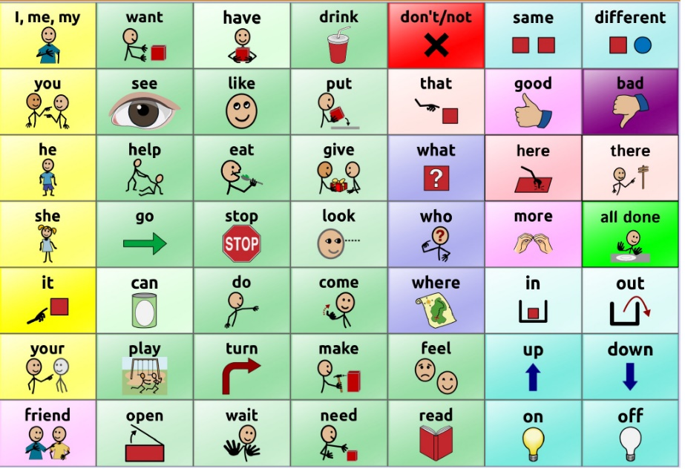TouchChat WordPower 42 Basic
READING
Here are some suggested books on YouTube that can assist in teaching the core word:
My First Word Book 📚 Usborne Books & More
(You can use this book by pausing on each page and asking the student, ‘what’ the items are, (e.g. What is that). This can build question formulation and vocabulary.

Polar Bear Polar Bear, What Do You Hear created by Justin Brannick

Dinosaur Rap | Barefoot Books Singalong
(Adults can ask what the dinosaur and people are doing).

SOCIAL INTERACTIONS AND VIDEO MODELING
Use social scripts for students to ask questions of one another. Many apps, have pre-programmed answers as to biographical information but we can expand from there:
What is your name?
What do you like to do?
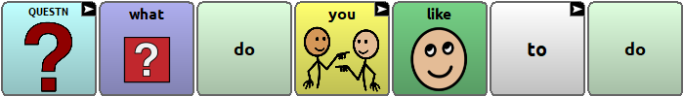

What do you like to eat?
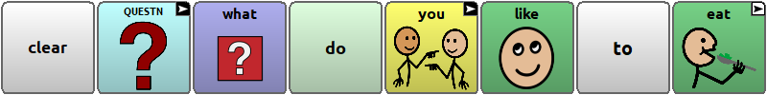
What stores do you go to?
The above was created in Chat Editor, a free software application from Saltillo that can be downloaded on a PC computer. It does not work on a Mac, unfortunately. The user area above reflects the TouchChat with WordPower 60 Basic. It also supports LAMP.
Another idea, during morning meeting(s), students can ask questions of the adult(s), (e.g. what are we doing today).... Or adults can model that question and then go over the schedule.
To make it a more interactive activity, students can gather in pairs to discuss the answers to the questions and then share with the group.

SENSORY MOTOR
Adults can form a circle and the leader makes a move or action. The adult can ask, everyone, ‘what did ___ do?’ and the other students and adults imitate. Each student takes turns being the leader.

STRUCTURED ACTIVITIES
Explicitly teach the word, what using a big core board, low-tech or use of a students’ AAC system. Indicate that it is a question word and ask some simple questions that you know they can answer in their AAC system and/or verbally. Expand to other, ‘what’ questions during the day.

Farm animal activity: Read a book about farm animals. Consider having a barn with animal figures during the reading and then talk about animal sounds. Make an animal sound and ask the student, ‘what makes the sound’ and see if they can model the answer in their talker(s). Students may need or benefit from Aided Language Stimulation support and/or a field of two choice, (e.g. bird or cow) to answer the questions.

Item hidden in a bag: Hide an item in a bag and allow the student to feel it but don’t open the bag. Use aided language stimulation to model asking the question, ‘what is it?’ Have the students describe what it feels like and to guess what it is. Open the bag for the big reveal. Repeat this fun activity using a variety of fun toys to play with and slowly pause and prompt to see if the student begins to spontaneously ask the question, ‘what is it?’

VIDEOS, MUSIC, ANIMATED SHORTS

The Present - OFFICIAL
During the video, stop and pause and ask what is happening.

What Do You Like To Do? | Kids Songs | Super Simple Songs

Song: What's Your Name?

Video Modeling - Asking Questions by Watch me Learn

ART OR SCIENCE ACTIVITIES

Adults can use cookie cutter shapes and ask what each student likes and once chosen, the student can trace the shape five times on the paper.
Then the adult can ask the student, what color they like and then they can paint it or color it in with the chosen color. (repeat for the 5 traced shapes) using aided language stimulation, emphasizing the word, ‘what.’

USE OF APPS OR OTHER TECHNOLOGY

SoundTouch app: Utilize the soundtouch app to find animals, vehicles, instruments and home items and listen to what sounds they make. The adults can ask, ‘what says moo?’ and other various sounds.

Use Clicker Writer for writing words, phrases or sentences with picture support as well as word banks to support a writing activity with a focus on the word, ‘what.’

WORD WALL: Add the word, what on the Word Wall.

READING and the Word Wall: Sound out the letters together. Have the students find the word on the AAC system.

WRITING and the Word Wall: Using a pencil or alternative pencil, have students try to type the word on the keyboard or write the word together.

Choosing Words for the Classroom Word Wall with Dr Caroline Musselwhite Video

For specific questions or more ideas regarding this core word Activity Sheet, please contact Michaela Sullivan @ michaelasullivan2@gmail.com
Thank you!

