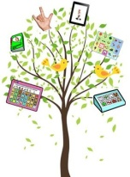
A Year of Words

Individuals who are learning to use their AAC systems need lots of practice on their core vocabulary words. This packet contains 12 grids of core words, one for each month. Speech-language pathologists, educators, and families can keep the grid of the month handy, and use it as a reminder of which words to focus on for that month. Over the year, you will have given the AAC learner focused practice on 144 words that will help them communicate effectively across many environments and activities.
How to Use: Determine which symbol set(s) your learners have in their AAC systems. Before the start of the month, insert the appropriate AAC symbol in each box and print the grid. Keep it handy as you provide focused language stimulation on those 12 words throughout the month. You may also want to share copies with the family and other team members.
:::::::::::::::::::::::::::::::::::::::::::::::::::::::::::::::::::::::::::::::::::
For more information on semantic intervention for individuals with significant communication challenges see our Vocabulary Instruction Round-Up at http://bit.ly/SKQP5W, a Pinterest board with activity ideas (http://bit.ly/ZJVOqK ), and a SpringPad (http://bit.ly/RPKosa ).
JANUARY WORDS
eat  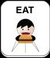 | 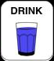  drink | 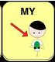  my
your  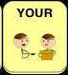 | 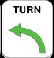  turn | 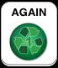  again
stop | 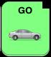  go | 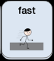  fast
slow  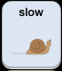 | 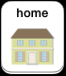  home | 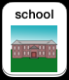  school

FEBRUARY WORDS
help  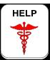 | 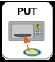  put | 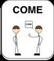  come
play  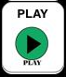 | 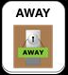  away | 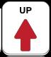  up
down  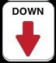 | 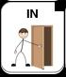  in | 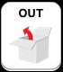  out
on  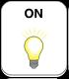 | 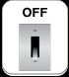  off | 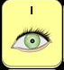  I

MARCH WORDS
it  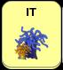 | 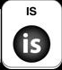  is | 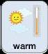  warm
hot  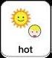 | 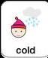  cold | 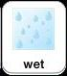  wet
dry  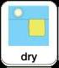 | here | 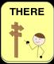  there
soft  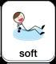 | ready  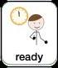 | 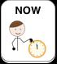  now

APRIL WORDS
can | walk | sing
quick | jump | run
loud | quiet | hear
dance | kick | throw

MAY WORDS
same | different | new
old | this | that
have | get | want
a | little | big

JUNE WORDS
give | some | me
push | pull | hit
thanks | please | no thanks
sorry | fall | mine

JULY WORDS
make | clean | dirty
wash | do | fix
broken | mum | dad
all done | you | what

AUGUST WORDS
feel | angry | happy
sad | scared | sick
tired | pain | why
not | finished | who

SEPTEMBER WORDS
need | more | wait
when | where | like
how | open | close
read | work | we

OCTOBER WORDS
first | then | next
good | bad | silly
hello | how are you | okay
beautiful | careful | beautiful

NOVEMBER WORDS

DECEMBER WORDS

