Mad Libs

Pronoun
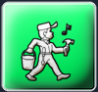 Action/Verb +ing
Action Verb
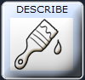 Adjective
Adverb
Preposition
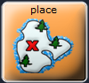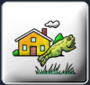 Place
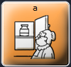 Noun
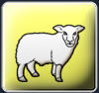 animal
Name
Feeling
Color

Once upon a time |  | went to the | .
 | (NAME) |  | (PLACE)
 | was |  | for
(PRONOUN) |  | (VERB +ing) |  | (NOUN)
But, |  | couldn’t |  |  | it.
 | (NAME) |  | (ADJECTIVE) | (VERB)
So the |  |  | granted |  | three wishes.
 | (COLOR) | (ANIMAL) |  | (NAME)
His first wish was | to always feel | . | The second wish | was to never | get stuck
 |  | (FEELING)
 | a | . | The final wish | was to
(PREPOSITION) |  | (ANIMAL) |  |  | (ADVERB)
have fun!

