CORE WORD: Win
For Educators, Related Service Providers and Parents
Wait Time: Last month we addressed Aided Language Stimulation, this month we take a look at wait time. Providing adequate ‘wait time’ is an important consideration for communication partners while interacting and engaging with persons who use AAC systems. Sometimes the need to ‘wait’ may seem uncomfortable at first but over time, practice and when given focused attention, the amount of wait time needed for each individual will become more natural. As communication partners we can wait expectantly for AAC users to respond and engage.
WAYS WE CAN USE THE WORD
SHARE INFORMATION (e.g. You win!)
ASK QUESTION (e.g. You win?)
REQUEST (e.g. help me win)
COMPLEMENT (e.g. nice win)
‘To win’ can often be confused with ‘first place’, it may help to teach these two in contrast.
Here’s how I interpret the difference, “Number 24 is my best friend. He scored so many points during the game which in turn helped his team to win and I felt like I won too because I was proud of him!”
(MUST SEE) Nevada at New Mexico || Best Comeback in NCAA History! Down 14 Points with 2 Minutes Left
ROUTINES AND SCHEDULES
Arrival: Adults can treat coming to school as a race with a ‘finish line’ by the door. All it takes is chalk or duct tape! Adults can tell students “you win!” when they get to school. Students can indicate that they “win” when they get to school. During this winning moment, adults can hand the students a laminated copy of the icon that can be used during attendance.
Snack/mealtimes: Students can use “win” after they tried new food for the first time, and they liked it. Another time a student can ‘win’ during snack time is if they do something they have never done before such as opening their lunch box.
Circle: Students can use “win” after they share during circle time. Adults can model this use of the word by saying “sometimes we get nervous to share at circle time, even sitting in front of the class. You win when you share with the class and we win when we are being good listeners.”
Clean-up Time: Students and adults can use “win” during clean up to point out who helped the most (e.g. you win because you helped all of your friends clean up). Adults can set up a finish line by all of the bins where toys go and teach students that when they are done cleaning up and have made sure they helped where they could - they win!
PLAY
Toys and Games: Using the student’s favorite toy, adults can support some moments during pretend play to use ‘win.’ If a student loves dinosaurs there can be a dinosaur race, and so on.
Recess
Students can use win during recess to indicate that they won a game. Students can also use win to compliment a friend’s performance (e.g. “you win”).
READING
Here are some suggested books on YouTube that can assist in teaching the core word:
Winners Never Quit by Mia Hamm read aloud by Learning with Mrs. Lammers
Bat's Big Game by Margaret Read MacDonald read by Ms. Heather
Number One Sam" by Greg Pizzoli Read Aloud Tandem, Partners in Early Learning
SOCIAL INTERACTIONS AND VIDEO MODELING
In a more structured social interaction situation, adults can facilitate a ‘good friend metal exchange’ in which all of the students use “you win.”
Here is an example of something that can be created to emphasize that ‘winning’ moment:
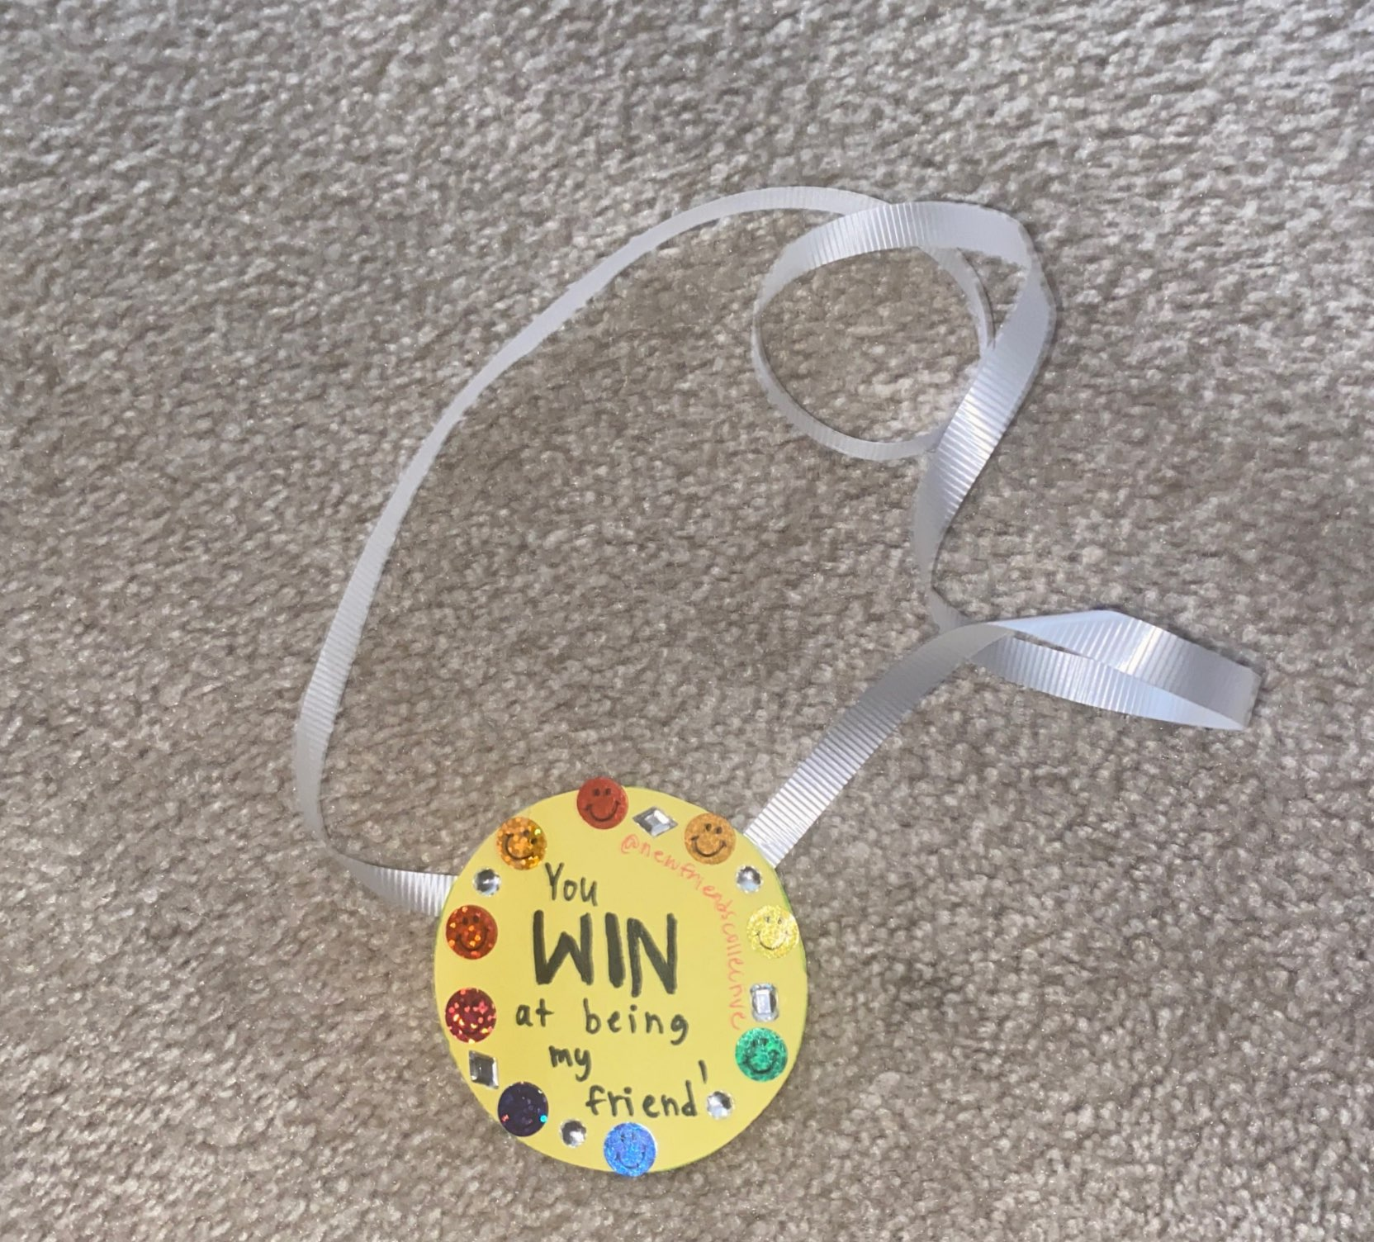
SENSORY MOTOR
Students can practice drawing finish lines on the playground or during physical education classes and say “I win” when they cross it! Students can cross the finish line however they’d like - skip, stop, tiptoe or jump!
Students and adults can play minute to win-it games. The following link can help with modeling these activities!
KIDS MINUTE TO WIN IT GAMES / Jake and Ty
If there are a lot of people available, students and adults can work together to complete a relay race. Different people can have different jobs during this relay race: someone can jump, someone can climb, someone can go down the slide and so on.
STRUCTURED ACTIVITIES
Adults can explicitly teach this word, to ‘win’ means we worked hard on something, practiced a lot and then something happened that made us feel good!
Adults can use the following video to help teach ‘win’:
Good Habits for kids | Don't Cheat to Win | Moral Stories | Polly Olly
ART OR SCIENCE ACTIVITIES
Winning can look different for everyone depending on what sport or hobby they are interested in, below is an impressive video of someone winning a spelling bee!
Insert name here’s Finish Line:
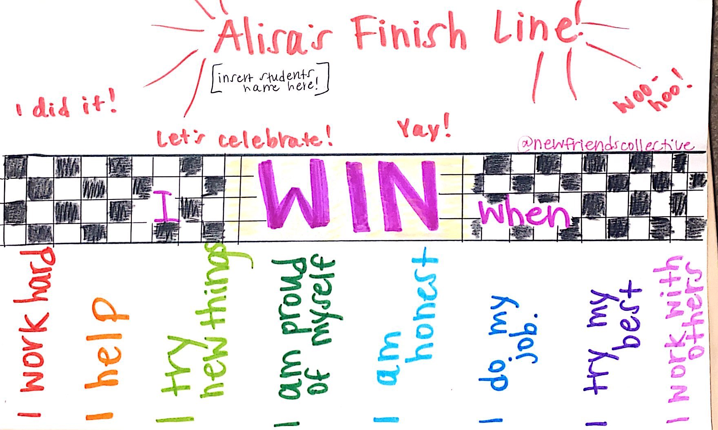
A finish line is only as special as all of the work that goes into getting there. If you are reading this, you are working hard in order to support these students, and these students work hard. Let’s celebrate every step of winning!
USE OF APPS OR OTHER TECHNOLOGY
Pictello: Using paid app Pictello or free website Tar Heel Reader (tarheelreader.org)or any other story generating app, google slides, PowerPoint, etc. create a “I Win When” story for the student(s) and describe what it means to win using any of the above activities and the moments that stem from those. Read the story with the students.
VIDEOS, MUSIC, ANIMATED SHORTS
Here are some different video examples of what it may look, and sound like to ‘win.’
You Can Win the Race I KLS Nursery Rhymes & Kid Songs
The Best Race Comeback You Will Ever See - Good Morning America
WORD WALL: Create a WordWall and add ‘win’ to the list.
READING and the Word Wall: Sound out the letters together. Have the students find the word on the AAC system.
WRITING and the Word Wall: Using a pencil or alternative pencil, have students try to type the word on the keyboard or write the word together.
For specific questions or more ideas regarding this core word Activity Sheet, please contact Alisa Lego on Instagram @newfriendscollective.
To whoever is reading this, YOU win!

CORE WORD: Lose
For Educators, Related Service Providers and Parents
Wait Time: Last month we addressed Aided Language Stimulation, this month we take a look at wait time. Providing adequate ‘wait time’ is an important consideration for communication partners while interacting and engaging with persons who use AAC systems. Sometimes the need to ‘wait’ may seem uncomfortable at first but over time, practice and when given focused attention, the amount of wait time needed for each individual will become more natural. As communication partners we can wait expectantly for AAC users to respond and engage.
WAYS WE CAN USE THE WORD
SHARE INFORMATION (e.g. I lose!)
ASK QUESTION (e.g. You lose?)
REQUEST (e.g. lose help)
COMFORT A FRIEND (e.g. sorry you lose it)
DIRECT ACTION (e.g. lose there)
ROUTINES AND SCHEDULES
Arrival: Students could use ‘lose’ if they left something in the car and they need it.
Snack/mealtimes: Snack time has a lot of moving parts, students could use “lose” during snack time if they dropped a cracker or if something is not in their lunch box.
Circle: Students could use “lose” during circle time if they forgot any part of their communication system, anything from their glasses to their speech generating device.
PLAY
Toys and Games: Students can use “lose” if they are looking for a toy and it’s not in its usual spot.
Recess: Students can use “lose” during recess if they can’t find what they are looking for, such as a basketball.
READING
Here are some suggested books on YouTube that can assist in teaching the core word:
With any book,
SOCIAL INTERACTIONS AND VIDEO MODELING
When students miss their friends, they can say “lose” to let people know they are looking for someone specific.
SENSORY MOTOR
Put objects in a pillowcase and have an empty pillowcase on deck too! Have the students pick toys out of the bag, and when you surprise them with the empty pillowcase - use that moment to teach the word ‘lose’.
STRUCTURED ACTIVITIES
Adults can explicitly teach the meaning of this word. ‘To lose’ can often be confused with ‘getting last place’. These must be never taught together as they are not the same. For the purpose of teaching the meaning of the word, let’s use the definition of “something is not where it should be, and I want it.”
Go on a scavenger hunt wherever you are and explain the lost and found and how we use it!
ART OR SCIENCE ACTIVITIES
With any art supplies available, students can decorate a piece of paper and leave a blank part. In this blank space, students and adults can place the symbol for ‘lose.’
USE OF APPS OR OTHER TECHNOLOGY
Pictello: Using paid app Pictello or free website Tar Heel Reader (tarheelreader.org)or any other story generating app, google slides, PowerPoint, etc. create a story about anything and leave some pages blank on those pages put the students symbol for ‘lose.’
VIDEOS, MUSIC, ANIMATED SHORTS
Play any video at all and randomly turn it off. When you look at the student in feigned shock say, “where did it go?!” - use this moment to teach and practice ‘lose.’
Lost and Found - By Oliver Jeffers
WORD WALL: Create a WordWall and add ‘lose’ to the list.
READING and the Word Wall: Sound out the letters together. Have the students find the word on the AAC system.
WRITING and the Word Wall: Using a pencil or alternative pencil, have students try to type the word on the keyboard or write the word together.
For specific questions or more ideas regarding this core word Activity Sheet, please contact Alisa Lego on Instagram @newfriendscollective.

CORE WORD: Those

For Educators, Related Service Providers and Parents
Wait Time: Last month we addressed Aided Language Stimulation, this month we take a look at wait time. Providing adequate ‘wait time’ is an important consideration for communication partners while interacting and engaging with persons who use AAC systems. Sometimes the need to ‘wait’ may seem uncomfortable at first but over time, practice and when given focused attention, the amount of wait time needed for each individual will become more natural. As communication partners we can wait expectantly for AAC users to respond and engage.

WAYS WE CAN USE THE WORD

INSTRUCT: (e.g. we need those books, get those reports turned in by Friday)
REQUEST: (e.g. Can I have those? I will take one of those)
COMMENT: (e.g. Those pants look great)
ASK A QUESTION: (e.g. What are those? Do we agree on those rules?)
INFORM: (e.g. Those are mine, I used to watch those shows)
DISAGREE: (e.g. I don’t like those shoes, I do not think those go together)

ROUTINES AND SCHEDULES
Daily Routines
Adults can model the word, those, on the student’s communication system(s) when appropriate in daily activities or tasks such as mealtime, schoolwork, and circle time. Add 1-2 more words to the length of utterance usually expressed by the student, and when modeling, focus on target phrases that may be used again in daily routines. For example, as you model the word, those, you can add further meaning (e.g. “those mine”, “want those”).
Activity Centers: Students can indicate what materials belong to them or what materials they wish to use with the core word when appropriate (e.g. those are mine, those mine, want those, I like those, not those). The strategy of the month, giving two choices, can be incorporated by adults through modeling and using the words choices, those/not those or using the choices, these/those (typically, ‘these’ is used for plural and near items, and ‘those’ for plural and further away items). Adults can place similar items in two different, spaced out locations and then ask questions such as, “do you want to use these colored pencils? Or do you want to use those markers over there?” Also, adults can take items they know belong to a student, and ask, “whose colored pencils are over here” to provide the student an opportunity to use, “those mine” or “those are mine”, “not those” etc.

PLAY
When students are selecting toys or putting toys away, they can be prompted to make choices using the core word (e.g. those mine, want those, I like those, not those). Adults can also ask questions when getting out toys to demonstrate use of the core word, using phrases such as: “ohh, you want those toys?”
Adults can also put toys they know a student prefers somewhere far away from the student or somewhere out of reach to set up an appropriate context for using the core word (e.g. you want those toys up there? You want those markers? Are those the toys you want?)

READING
Here are some suggested books on YouTube that can assist in teaching the core word:
Many books can be used, and adults can talk about different things on the pages (e.g. “Look at those! What are those? Do you want those?)
Those Shoes By Maribeth Boelts, Read Aloud by OBKidz https://www.youtube.com/watch?v=LjUFJEduguk&ab_channel=OBKidz
Those Darn Squirrels By Adam Rubin, Read Aloud by Miss Grant’s Reading Rug https://www.youtube.com/watch?v=48aqkyDk2Fw&ab_channel=MissGrant%27s ReadingRug

Those Pesky Rabbits by Vinca Alvaraca, Read Aloud by Stories 4 Nauru https://www.youtube.com/watch?v=ArGov1bnCIU&ab_channel=Stories4Nauruh

SOCIAL INTERACTIONS AND VIDEO MODELING
During activities throughout the day, it can be discussed when an item does or does not belong to the student. For example, during math or reading, an adult can model: “Are those your papers?” “Are those your pencils?” “What are those?”
Assign student pairs to interview each other, providing questions (along with visual cues), (using the symbols and words as/if needed) regarding items that belong to them, or their friends, etc. Assist students in formulating their responses by asking probing questions and by using aided language stimulation. After all students have completed this activity, they can share out to the rest of the class (e.g. those are my friends, those are my pets, I like those shows, I love those shoes, those are my toys).
Video Modeling: A video could be created of items that belong/do not belong to the student. In the video and with the help of an adult model, it can be discussed, whose is that? Are those your shoes? Are those your pants? Are those your glasses? Those are not your toys. etc.
Or a video can be shown with anything such as toys/songs/shows/movies that may or may not be of interest to a student to prompt a student to use the core word in phrases such as: I love those toys, I do not like those, I want those, I used to watch those shows, etc.

SENSORY MOTOR
Students can have their shoes removed and placed somewhere in the room, then they have to go find their shoes and proclaim, “those are mine!”
Adults can blow bubbles far away from the student or blow the bubbles high above the head, and then use the core word in phrases such as: look at all those bubbles! Those bubbles are flying away! Those bubbles just popped! Where did those bubbles come from? Where did those bubbles go?
Adults can put items in a big bin (box of colored pencils, bag of marbles, pair of shoes, glasses, etc.) and have the student reach into the box and pull things out and then model use of the core word: what are those? Those are______.

STRUCTURED ACTIVITIES

RUN AND TOUCH GAME: Adults can call out items in the room using word, those, and have students go to touch the items the adult calls out. Additionally, adults could set up distinct items far away from the front of the room, like a stack of books, stack of toys, etc. Then, the adult can point and call out the different objects using the core word; “go touch those desks”, “go touch those books”, “go touch those teddy bears”. Adults can provide students an opportunity to use the core word, and have the students point and call out objects they want their classmates to go and touch.
ITEM IDENTIFICATION: The adult can take pictures of all the students’ shoes in the class and put them into a PowerPoint. Then, the adult can go through the PowerPoint and ask a question such as, “whose shoes are here?” Students could have a chance to guess who they think the shoes belong to, to add to the engagement, and the adult can incorporate more examples of the core word in use (e.g. I think those might be ’s shoes, I think I know those shoes, I think I have seen those before). Then, students can take turns calling out when they see their own shoes, with prompts to use a phrase such as: those mine, those are mine, those are my shoes. A different variation of the game could be taking pictures of recognizable shoes or other items from various professions (e.g. clown shoes, firefighter boots, scuba flippers, high heels, construction boots) and have students make guesses to who would wear those items: those are clown shoes, those are skis, those are for scuba diving.

ART OR SCIENCE ACTIVITIES
Almost any science or act activity can be planned to incorporate the use of the core word, those. Adults can adapt their science or art lesson and look for ways to emphasize and frequently use the word, those, throughout the lesson to demonstrate the word across multiple contexts. For example, if watching a science video, an adult can make sure to ask the students: what are those? Have you seen those before? Those are awesome!
How to Make Rock Candy with Kids by Ally Noal (Adults can make rock candy and use the core word, those, when describing the activity. “Those are called crystals! Those crystals are growing. Look at all those crystals forming!) https://mommypoppins.com/kids/how-to-make-rock-candy-with-kids

Flock of Birds Create Beautiful Shapes in Sky by DailyPicksandFlicks (Adults can play the video and ask students questions with the core word such as: what are those? Look at all those birds? Those are amazing shapes? Adults can also prompt students to try and use the core word when describing what they see in the video: we watched those birds fly, those were birds flying, look at those birds go. https://www.youtube.com/watch?v=bb9ZTbYGRdc&ab_channel=DailyPicksandFlicks

USE OF APPS OR OTHER TECHNOLOGY
Any app could be arranged to incorporate modeling use of the core word, those, during game play. Adults can use apps with the student and look for ways to emphasize and frequently use the word, those, throughout play to demonstrate the word across multiple contexts. For example, while playing an adult can make sure to ask the students: what are those? Have you seen those before? Those are awesome! I love those colors! Students can also be prompted to try to use the word, during game play: I want to use those! What are those? Adults can also incorporate the strategy of giving two choices during game play: do you want those? not those?
MyPlayHome App: This app can be used to explore a virtual neighborhood with different characters. Throughout the game, the characters can perform different actions and explore places such as a home, school, grocery store, etc. Adults can model the word those throughout game play (e.g. Should we use those? What are those? Should we use these characters or those characters?) Or, students can use the word those to indicate when they want something (e.g. Those shoes. Those toys.)

MyPlayHome Part 2 - Ipad App Demo for Kids by Smart Apps for Kids https://www.youtube.com/watch?v=3gfryrBqMcM&ab_channel=SmartAppsforKids
My School Avatar App: This app allows students to create and personalize their own avatar characters. The avatars are animated, and students can add their own voice messages to be used by the avatar. Students can express themselves however they want, and if students are shy, they may be more comfortable having their avatar express their message. During use of the app, the core word can be modeled by adults by commenting or asking questions: Look at those ears! I love those glasses you chose. Look at all those colors! What are those? Students can also be prompted to use the core word during game play by the adult modeling or prompting I like those glasses, I do not want to use those, I love those shoes.
Cooking Mama: Let’s Cook! App: The app allows students to electronically cook meals step by step. Each step in the recipe requires different motions and easy touch controls. Students can cook a variety of foods and simulate the process of creating meals.

Kid in Story- Create or retell a story featuring the student. The story could be
about their day at school, or toys they wish they want to buy, shows they love. Use pictures of the student in the story along with the items. Then the student can practice use of the word, those, in their story (e.g. those are my friends, I want those toys, I love those shoes, those are mine).

Abilipad could also be used for writing with use of pictures, adaptable
keyboard, word banks, and word prediction. Pictures of different items that
would require different demonstratives before them (this/that/these/those) can be created, to practice using the words in the appropriate context.
h ttps://appytherapy.com/abilipad/

VIDEOS, MUSIC, ANIMATED SHORTS
Videos and Animated Shorts
Here are some cute, funny, brief video clips of young children using the core
word, those, that can be used as examples of the appropriate use of the word.
They’re Called My Sandals (What Are Those) Uploaded by Juan Vazquez https://www.youtube.com/watch?v=kR2O_xuVvIU&ab_channel=JuanVazquez

Look at All Those Chickens Uploaded by Raw Uncut Vines

https://www.youtube.com/watch?v=NsLKQTh-Bqo&ab_channel=rawuncutvines Animated Shorts
Snack Attack (2012), Andrew Cadelago and Eduardo Verastegui (This short shows an encounter between an elderly woman and a teenager waiting for the train, when there is a mix up between their snacks. The film does not have any speaking roles, and can provide an opportunity to model and ask questions
using the core word: are those his cookies? Are those the grandma’s cookies? Whose cookies are those?) https://www.youtube.com/watch?v=38y_1EWIE9I&list=PLlbkyhAZrBl-XJQudaCfo MsGy_Jjau6HE&ab_channel=EduardoVerastegui
Music
I See the Light from Disney’s Tangled, Uploaded by DisneyMusicVEVO (Song features word, those, several times. The lyrics are also displayed during the song as a sing-a-long.) https://www.youtube.com/watch?v=ILRs2r6lcHY&ab_channel=DisneyMusicVEV O
This, That, These, and Those Song by Encounter ESL https://www.youtube.com/watch?v=43WBw6ChGMs&ab_channel=EncounterESL

WORD WALL: Create a WordWall and add ‘those’ to the list.

READING and the Word Wall: Sound out the letters together. Have the students find the word on the AAC system.
WRITING and the Word Wall: Using a pencil or alternative pencil, have students try to type the word ‘those’ on the keyboard or write the word together.

For specific questions or more ideas regarding this core word Activity Sheet, please contact Andriana Nikolau @ andriananikolau@gmail.com
Thank you!

CORE WORDS: What’s Up?
For Educators, Related Service Providers and Parents
Wait Time: Last month we addressed Aided Language Stimulation, this month we take a look at wait time. Providing adequate ‘wait time’ is an important consideration for communication partners while interacting and engaging with persons who use AAC systems. Sometimes the need to ‘wait’ may seem uncomfortable at first but over time, practice and when given focused attention, the amount of wait time needed for each individual will become more natural. As communication partners we can wait expectantly for AAC users to respond and engage.
WAYS WE CAN USE THE WORD
SHARE INFORMATION (e.g. I want to tell you what’s up with me and why I have not been here.)
COMMENT (e.g. What’s up with that?)
ASK QUESTIONS: (e.g. What up with you? Or a different kind of question, What’s up in the sky?)
ANSWER QUESTIONS (e.g. So that’s what’s up with me)
EXPRESS A FEELING (e.g. I’ve been feeling ____ because of what’s up with me)
CLARIFY (e.g. So what’s up is that _______)
ROUTINES AND SCHEDULES
Morning meeting: During morning meetings, students and adults can ask each other, what’s up with you?
Arrival: When students come into class, adults and peers can greet each other and ask, ‘what’s up?’

PLAY
During game playing, adults can join the students and ask, ‘what’s up’ using aided language stimulation.
Hopefully, this will provide a platform for other students to also ask the question. This question could move into other questions about what is happening, in the here and now, (e.g. who’s winning, who’s losing, if the game is fun, etc.)

READING
Here are some suggested books on YouTube that can assist in teaching the core word: (or in this case, phrase, ‘what’s up?’)
What's Up Top? - Marc Martin read by Opa’s Corner Storytime
Duck and Goose: What's up, Duck? by Tad Hills, read aloud - ReadingLibraryBooks
What’s Up? / read aloud & pictures / a flip-flap- pop-up book read by Lina, (author unknown)
Sesame Street book with Bert and Ernie / What's up in the attic? / Read Aloud by Storybook Moments (A Little Golden Book, written by Liza Alexander and illustrated by Tom Cook.

SOCIAL INTERACTIONS AND VIDEO MODELING
Use social scripts for students to ask the question, ‘What’s up’ which can turn into an exchange of information, sharing ideas, and feelings. Using social scripts could be helpful for students who need more visual supports and scaffolding.
Adults can create social stories about the question’s students can ask each other when they see one another. For example, “When I see my friends, I can say, ‘hi’ and then ask, ‘what’s up?’ and then I can wait for an answer, (and so on).
Here’s some information and resources about Social Stories
Information by Carol Gray
How to Write a Social Story- The Vanderbilt Kennedy Center
Create a Greetings Wall Chart- Example by Loving Souls and Superstar Goals TPT
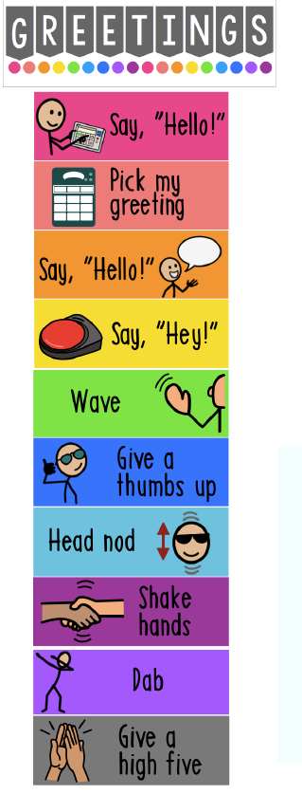

At morning meeting(s), students can ask questions of the adult or peers, (e.g. What’s up?) .... Or adults can model that question and then go over the schedule for the day.

SENSORY MOTOR
Adults can talk about the body movements or gestures students can use when they ask the question, ‘what’s up?’ Students can come up to the front of the room, one at a time to show how they ask the question and what movements, facial expressions or gestures they can make.

STRUCTURED ACTIVITIES
The question, ‘what’s up’ is a fun way of asking ‘what’s going on.’ Adults can incorporate this question into many fun aspects of the day as described above in other sections.

Adults could also introduce the question during a chart writing activity using a variety of pronouns and using picture/photo supports to bring context to the writing activity.

What’s up?
I am __________
We are ________
He is _________
She is _________
They are ________

VIDEOS, MUSIC, ANIMATED SHORTS

What's the Weather Like Today | Song Lyrics Video for Kids | The Kiboomers
Adults can ask their students, ‘what’s up’ with the weather and play the song.

Good Morning Song | Songs for Kids | Morning Song for Kindergarten | The Kiboomers (Adults can ask what’s up with them after this, ‘hello’ song).

A video about different types of Video Modeling(by May Beauburn, a Board-Certified Behavior Analyst at Brett DiNovi & Associates)
This phrase would be a great interactive video modeling activity. Here is a video that describes the various types of video modeling. Use video modeling to either watch others asking the question, ‘what’s up’ or video model them asking ‘what’s up’ using their AAC systems.

Young Adults
4 Non-Blondes - What's Up (Official Video) The adults can talk about how, ‘What’s up’ is another way of asking ‘what’s going on?’
What's Going On (Marvin Gaye) Feat. Sara Bareilles | Playing for Change | Song Around the World

Hilarious What’s Up? Budweiser Commercial

Budweiser | Checking in, that’s Whassup (Virtual during Covid 19)

ART OR SCIENCE ACTIVITIES
How to Make a Paper Bag Puppet | Parents
After the students have created their paper bag birds, they can use the puppet to ask each other, ‘what’s up?’

Students can make a collage of pictures either using paper, magazines, etc. or electronically using Google Slides and then discuss ‘what’s up’ and what’s been happening in their lives.

USE OF APPS OR OTHER TECHNOLOGY
Use Social Story Creator & Library app by Touch Autism where you can create, print and share stories. You can create or use the already, pre-made social stories. The app is free to create your own stories but most pre-made stories are not free. They have a wonderful social story for students about taking care of their device.

Google Slides- in a group. The adult can create a google slide presentation and create a separate slide for each student where the question posed at the top of the slide asks, ‘What’s up for your weekend?’ The students can respond, and the adult can write in what will be happening for each student.

WORD WALL: Add the word, (if the words have not been added add WHAT and UP) on the Word Wall.

READING and the Word Wall: Sound out the letters together. Have the students find the word on the AAC system.

WRITING and the Word Wall: Using a pencil or alternative pencil, have students try to type the word on the keyboard or write the word together.
Choosing Words for the Classroom Word Wall with Dr Caroline Musselwhite Video

For specific questions or more ideas regarding this core word Activity Sheet, please contact Michaela Sullivan @ michaelasullivan2@gmail.com
Thank you!

