How to say ‘my leg hurts’.
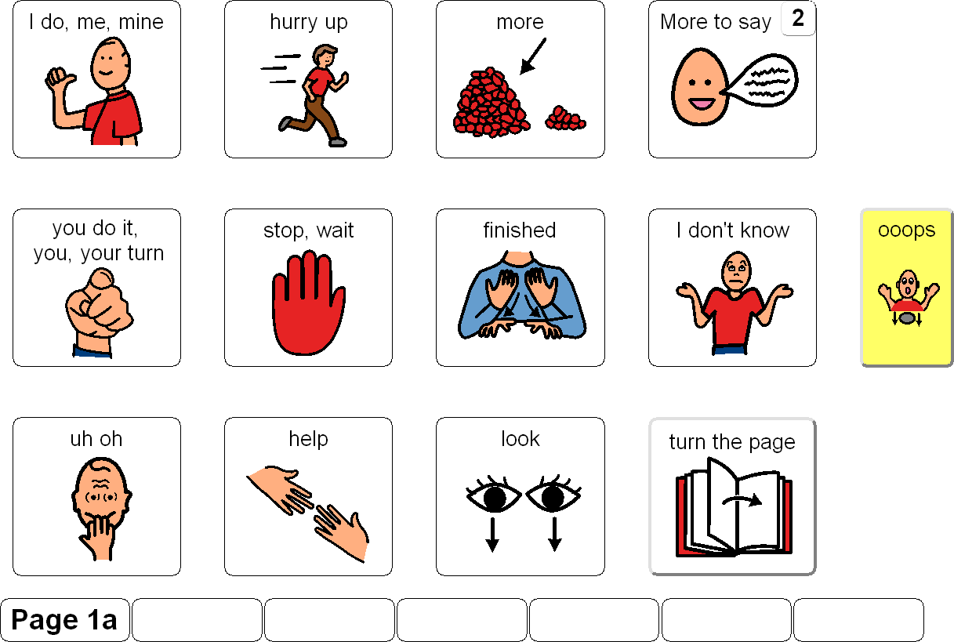 ‘More to say’- follow the number to page 2.

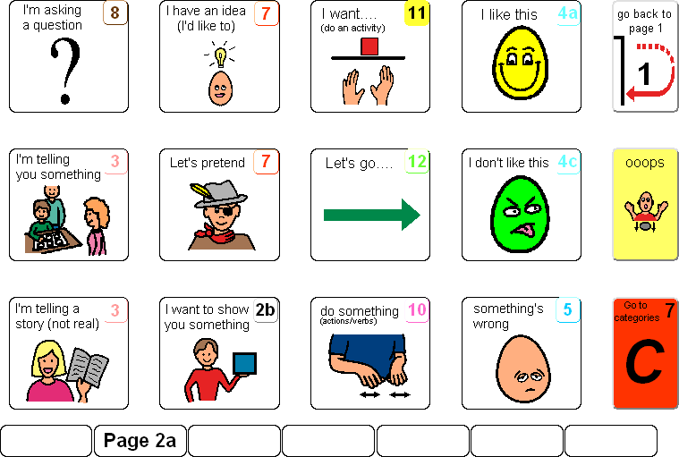 ‘Something’s wrong’

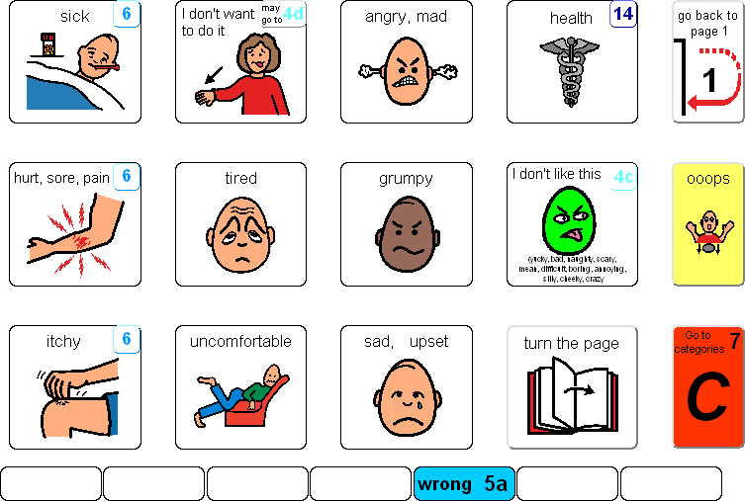’Something hurts’

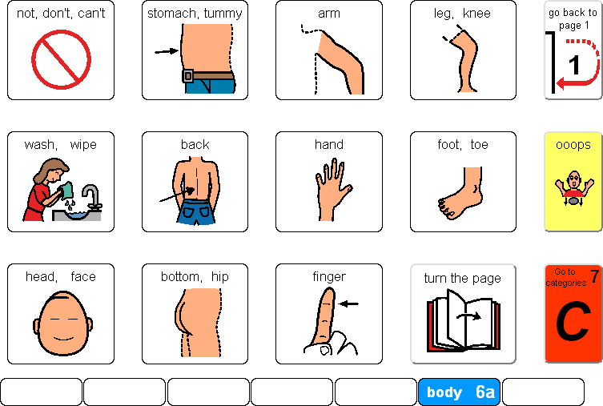’Its my leg.’

