Trick or Treat Cards
Know a little one with speech difficulties? Cut out these little cards to hand out when trick-or-treating.
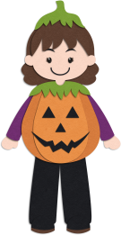  This little pumpkin has speech difficulties.  Please accept this as a great big  Thank You! |  | This little pumpkin has speech difficulties.  Please accept this as a great big  Thank You! |  | This little pumpkin has speech difficulties.  Please accept this as a great big  Thank You!
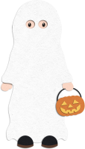  Oops! I can’t find my words.  If I could, I’d give you a big THANK YOU! |  | Oops! I can’t find my words.  If I could, I’d give you a big THANK YOU |  | Oops! I can’t find my words.  If I could, I’d give you a big THANK YOU
We all speak in different ways.  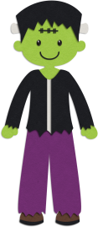  Here’s my way of saying Thanks & Happy Halloween! |  | We all speak in different ways.  Here’s my way of saying Thanks & Happy Halloween! |  | We all speak in different ways.  Here’s my way of saying Thanks & Happy Halloween!
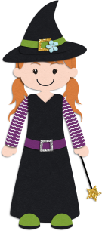  Talking is hard for me.  Here’s my way of saying Thanks & Happy Halloween! |  | Talking is hard for me.  Here’s my way of saying Thanks & Happy Halloween! |  | Talking is hard for me.  Here’s my way of saying Thanks & Happy Halloween!

